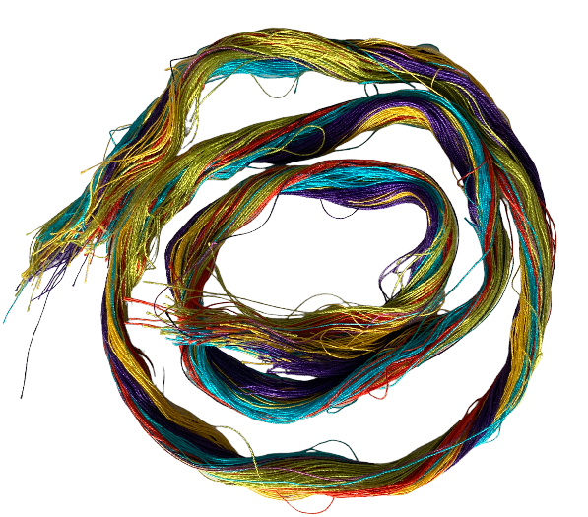
ZERO WASTE: LOOM WASTE

Everything in my ZERO capsule collection is zero waste in terms of pattern cutting and construction.
However, weaving does produce loom waste at the beginning and end of each warp, plus there are small samples woven to check for size, washability, shrinkage etc. So here are some of the ways I use these warp ends and samples to avoid any surplus, with some additional ideas I have also used at the end.
Yarn ‘waste’
Cardboard Weaving
The excess warp ends at the start and end of the cloth are idea for weaving patches and coasters.
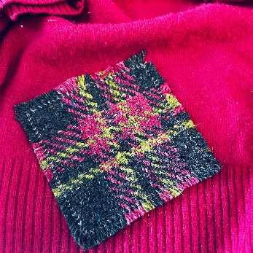
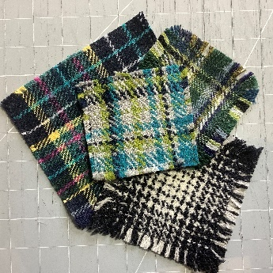
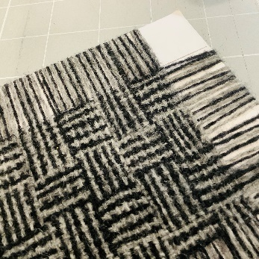
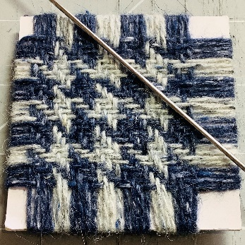

Visible mending and embroidery
Small lengths can also be used for embroidery and in visible mending projects.

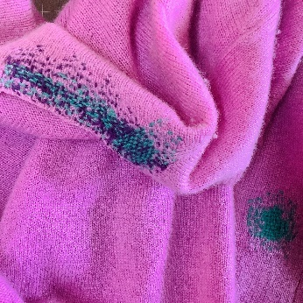
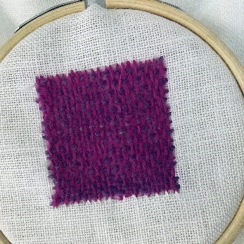

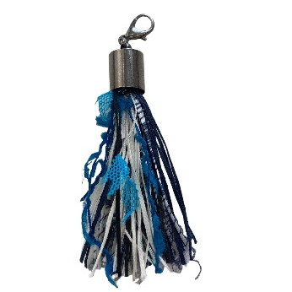
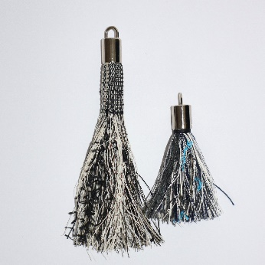

Tassels
Often I will hemstitch the very end of a warp to stabilise it for making into tassels, with the top of the tassel stabilised I can roll sections into various sizes of tassel for zip pulls or other decorative uses.

Kumihimo braiding
Using a simple cardboard or foam Kumihimo disc, create cords that can be used as drawstrings for bags, shoelaces and zip pulls. Or weave ‘friendship bracelets’.

Re-spin wool
I keep wool scraps separate from other fibres and sorted by colour. The I can card them and spin (I spin with 50% scraps and 50% new wool) into new yarn. It’s very satisfying!

Woven woollen selvedges and other small scraps can also be carded and re-spun.
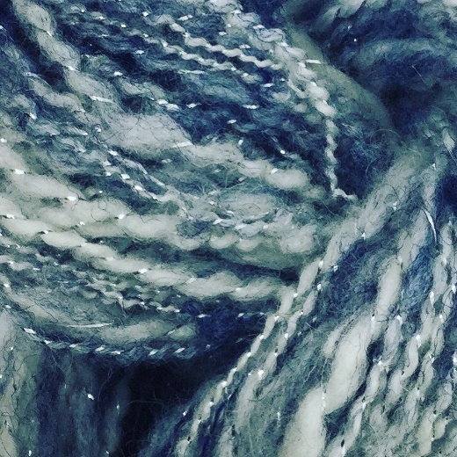
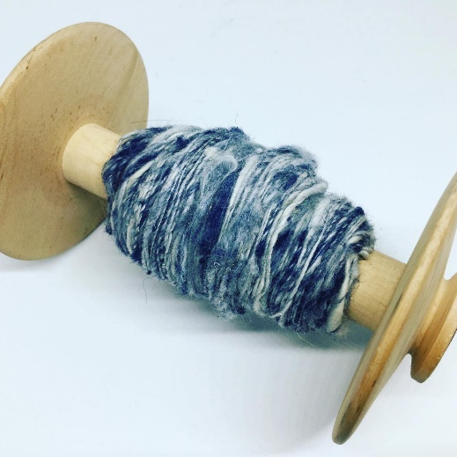

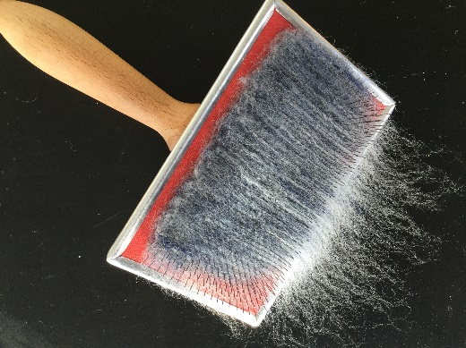

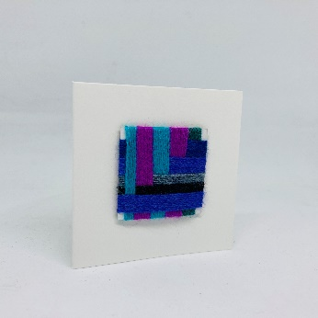
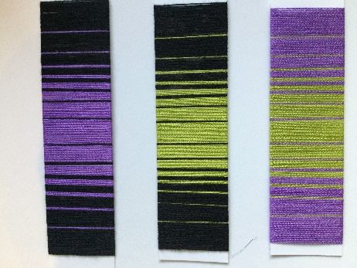
Yarn wraps
Yarn wraps to test colour combinations and proportions are an essential tool for a weaver and warp ends are ideal for this. Yarn wraps can be adhered to card to make gift tags.

Stuffing/ filling
Scraps that are too short for any of the above are used to stuff pincushions, Xmas baubles, doorstops and my woven footballs.
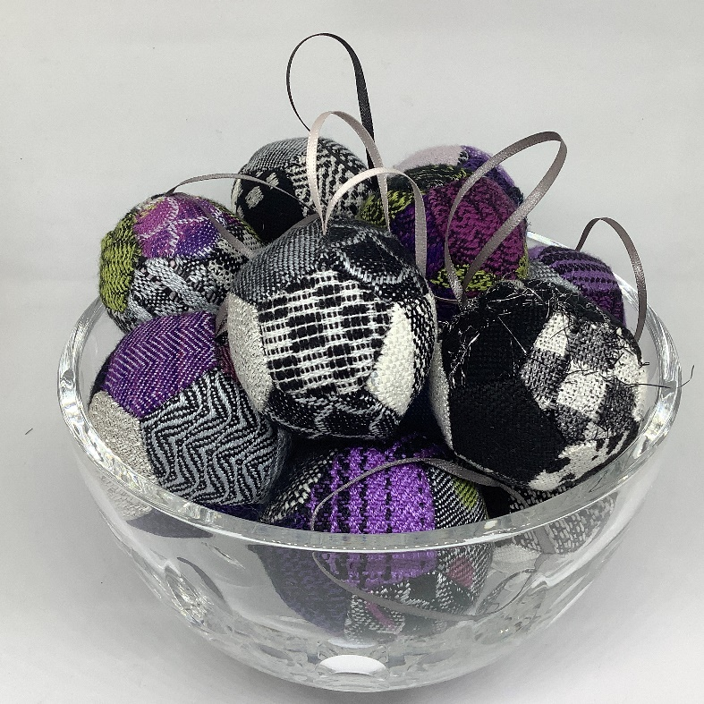
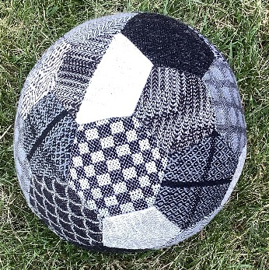

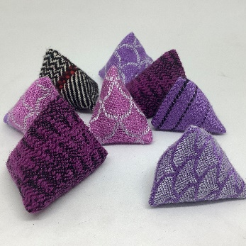

Other ideas to try
Inlay wefts
Tapestry Weaving
Pom Poms
Use warp ends as ‘string’ to wrap present

Samples and those last few inches of warp

Patchwork
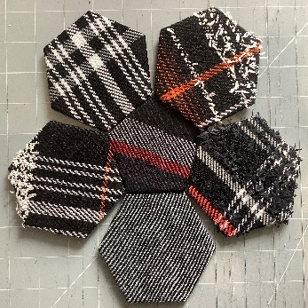
I always weave to the very end of each warp. After I have woven my project, I hemstitch it then weave the last few inches with leftover yarns and use the cloth for patchwork.
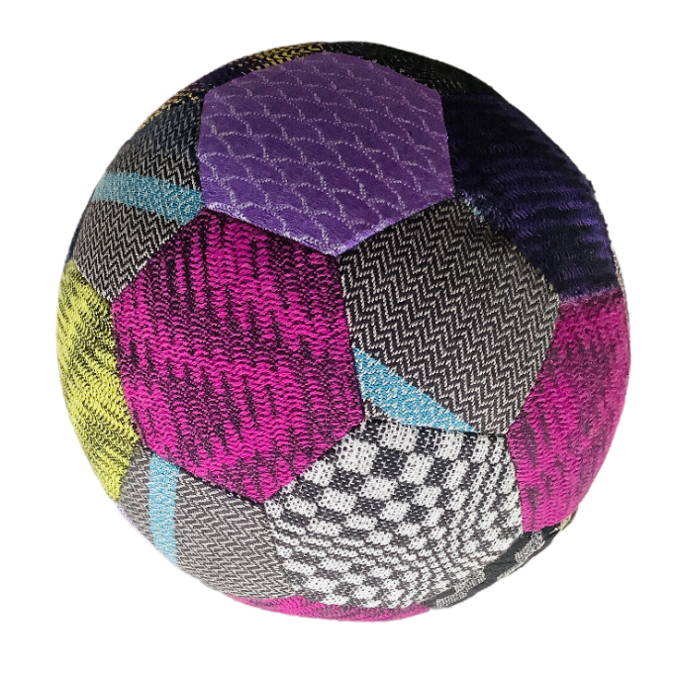

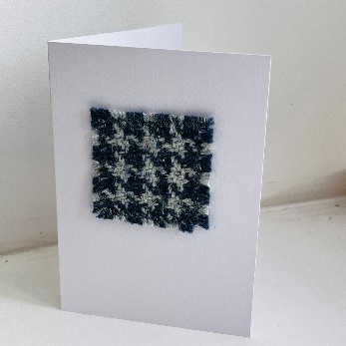
Gift cards, greeting cards
Tiny samples can be mounted onto cards for gift tags or cards.

Buttons
Self-cover buttons are readily available and are idea for very small pieces of cloth
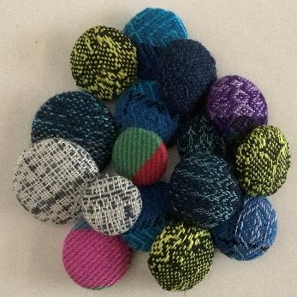

Other ideas to try
Lavendar Bags/Hearts
Brooches

